LEXINGTON Rich Wood Dining Set

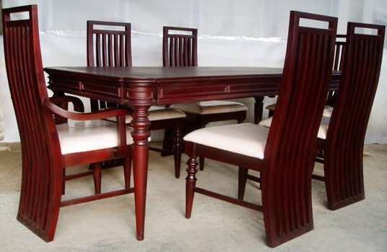

|  |
| --- |
| **DESCRIPTION** |
| LEXINGTON introduces stylish wooden dining set with a rich glow finish on top the set of tables and chairs is perfect to create the perfect the durable surrounding. The rich onyx wood on top enables potential to decorate objects with different styles and light touch feeling top and let’s not forget about chairs because they are built to summon relaxation. |

|  |  |  |
| --- | --- | --- |
| **Price** | **1840$** | |
| **Dimensions** | **Table H** x **W** x **L** | **50in x 40in x 50in** |
| **Chairs H** x **W** x **L** | **35in x 29in x 33in** |
| **Features** | **Six Chairs and One Table with on top and natural onyx wood will give a cool and relaxing smell will be obtained from it** | |
| **Finished** | **Brown Form** | |
| **Available in** | **Peach, Brown and Black** | |